PORSCHE 928 LOCKS BY WAYNE STRUTT winter 2012

HATCH LOCK REKEYING

This is my experience rekeying my hatch lock. Since I did not have a key that would unlock the hatch I did as suggested on the 928 forum.
First, from inside the hatch, I drilled a ¼” hole in the body frame about ¼” down from the top edge of the hatch in line with the lock receiver. Then, with my shoulder pressing against the inside of the hatch glass, I pushed a screw driver through the hole and released the lock and opened the hatch.
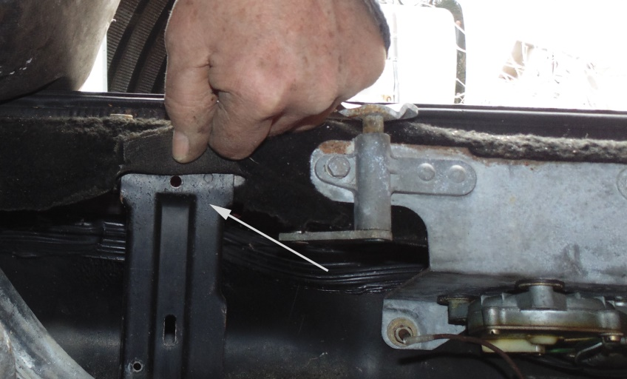
For cars with keyed alarm if you look overhead you will see a number of cap retainers that hold the finish trim to the inside of the hatch. These are 2 piece. Use a thin screw driver and pry the centre cap straight out. The piece remaining can be removed using pliers to squeeze the split together and pull out of the hole. Now pull down the trim to reveal the alarm wire harness. Unplug the alarm wires.

1
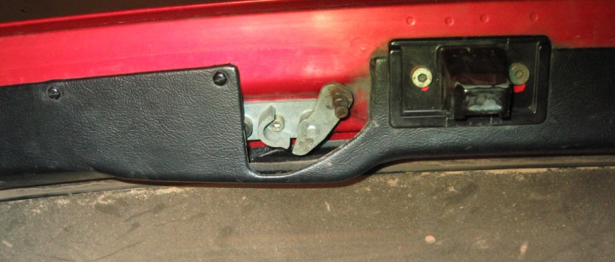

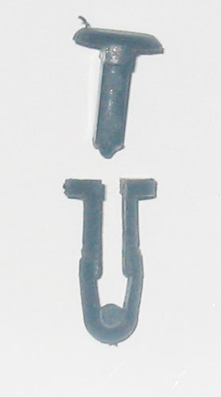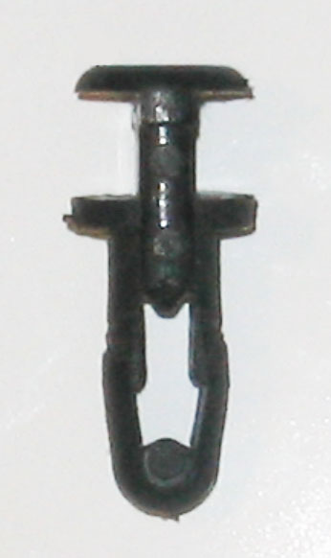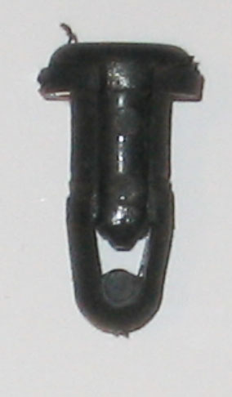
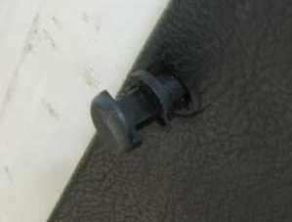

TRIM fastener

2

Using a 5 mm hex key Allen socket unscrew the 2, 10mm long hex drive cap-screws that hold the lock bracket to the hatch door.

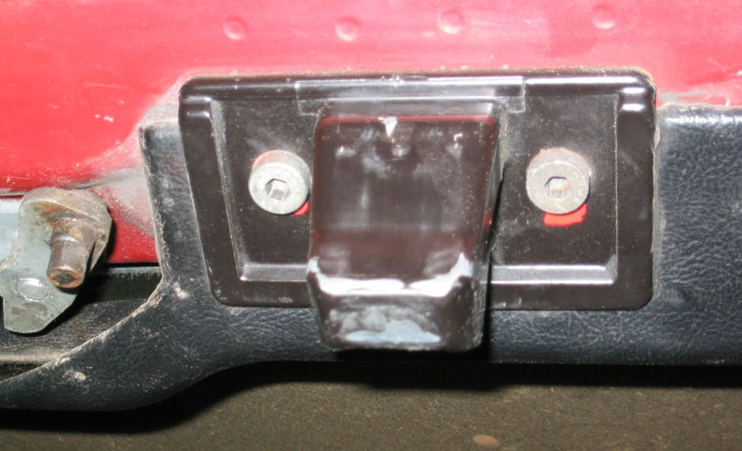

3
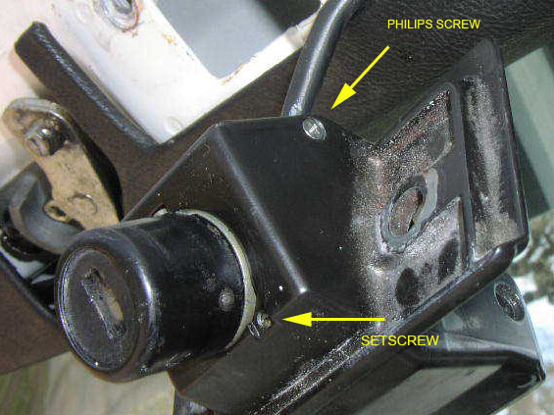

You now have in your hands a lock in a bracket (Alarm lock will have a wire with plug connector coming from it.) I am going inside now. 9 below zero makes your body shake too much to handle the tiny parts from here on.

4
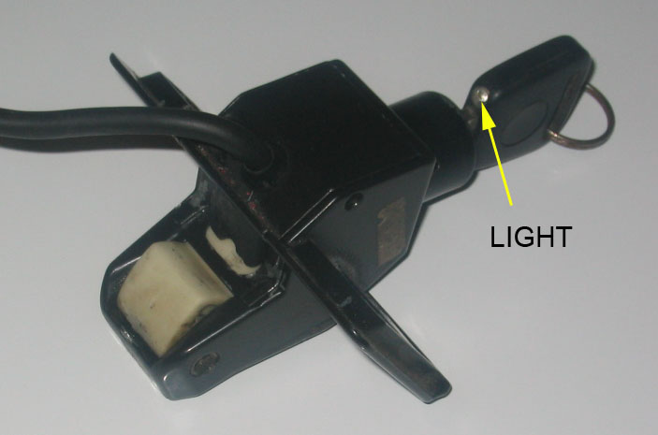

I have indicated the light for orientation as that would be the way you would normally insert the key.

Also from here you need:
A spring loaded Centre Punch,
A Drill
Some Verrrry Sharp Drill Bits, 1/16” and 3/32” to get the cap off the Barrel
no. 35 or 7/64” drill bit, for the
6-32 Tap,
1 set of small Screw Drivers (Philips and Slot)
Cleaning Solution (paint thinners)
Small paint Brush for cleaning
Tweezers
Masking Tape and
The largest Bedsheet you can find for when you drop one of the tiny springs.

and ………..Patience

5

On the sides of the bracket are small flat head Philips drive screws. Remove these and separate the underside portion of the bracket from the main part. With an alarm just move it out of your way as the wires run through it.

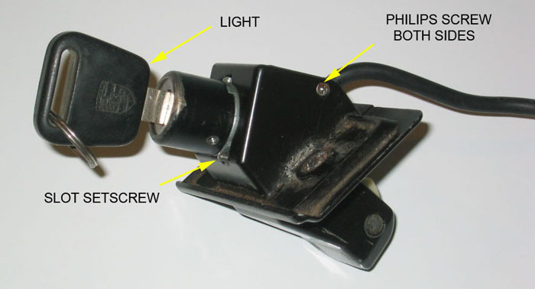

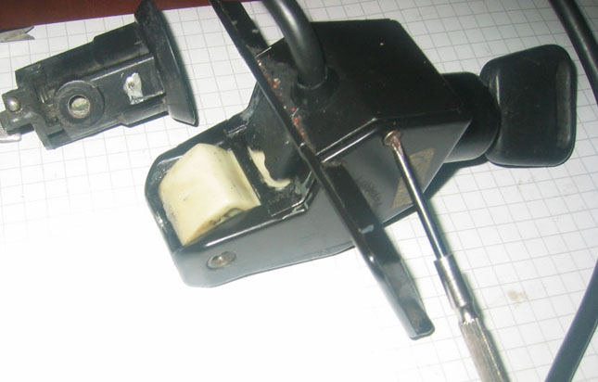

6

If you have an alarm lock you will see a black plastic cap. Pry that off.

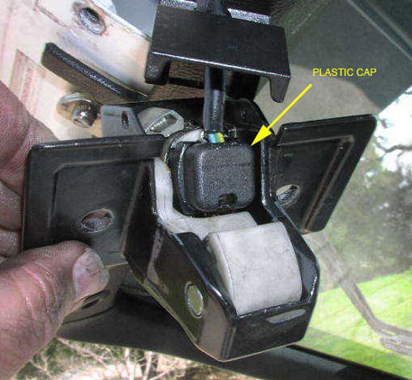

Remove the two small Philips screws that hold the plastic wire carrier to the barrel. Lift this off and you will see a copper contact finger. Remove the plate and rubber sealing gasket. Note and mark the position of the copper contact finger with the barrel, as it is important on reassembly that the contact finger moves from one copper contact to the other. The copper finger on the end is fragile so handle with care .

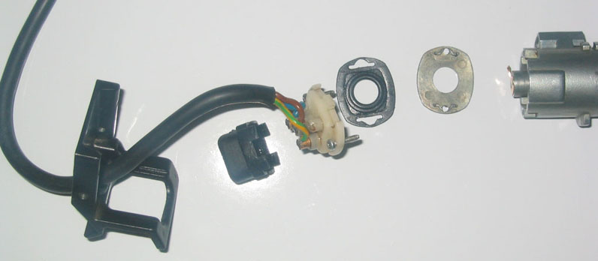

7
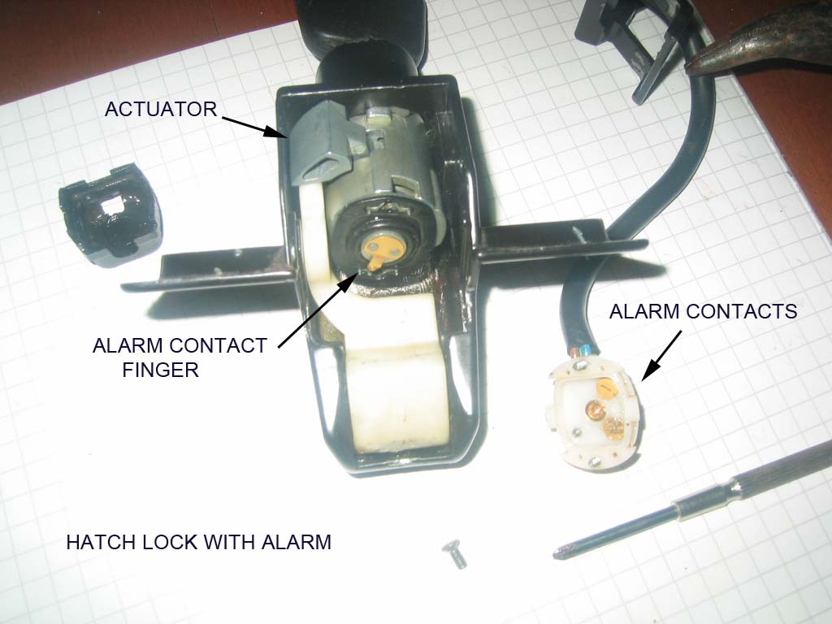

Now on the key entry side is a small flush slot head setscrew next to the barrel. Unscrew that to unlock and allow the barrel to rotate in the bracket counterclockwise. Line up the boss with the hole in the bracket. Push the barrel into the bracket to remove it from the bracket. Remember the copper contact. Hold the white plastic lever down to slide the barrel out without hitting the copper contact. The actuator on the side of the barrel will hinder this but it can be done.

8

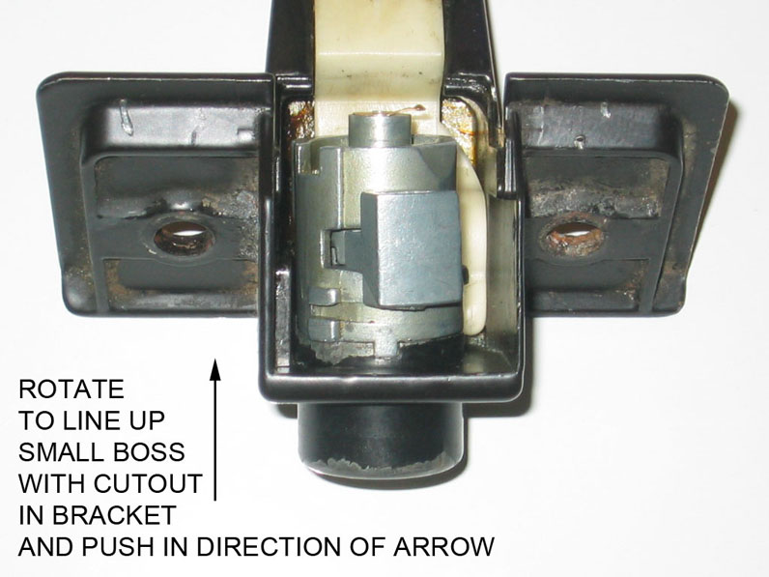

The barrel will have to be drilled on both sides to get the cap off. Use a centre punch to make a starting point and drill with a 1/16” bit approximately 1/16” deep. Stay centered, the bit will want to wander to the softer die cast zinc alloy barrel. Then using a 3/32” bit drill to the same depth again. The cap is .005'' thick and the barrel is 1/8”- .125” thick at this point. However if you drill more than .175"” deep you will hit the core and ruin the lock. Later what is left of the pins will just push out of the barrel

9

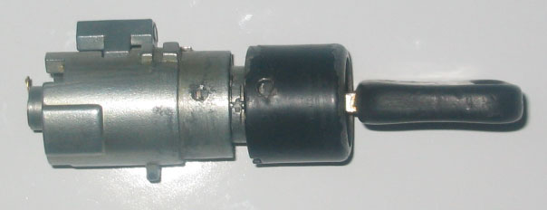

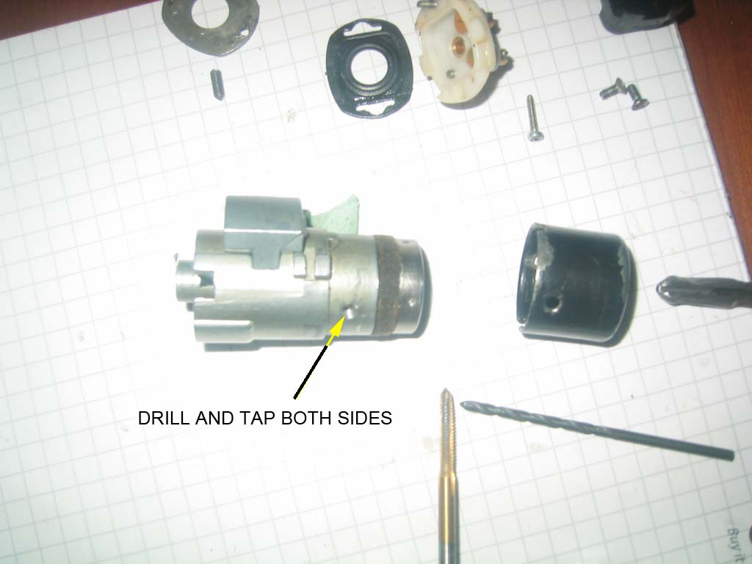

When you take the cap off make sure the core stays in the barrel. Use a thin blade and pry (ease), the cap off. Then REINSERT the key. I think the best way to restore the unfortunate need for drilling is to tap the barrel holes and install set screws or maybe cut off roll pins. But they only need to be about 3/32" to 1/8” long. Any longer and you will hit the core and prevent rotation.

10
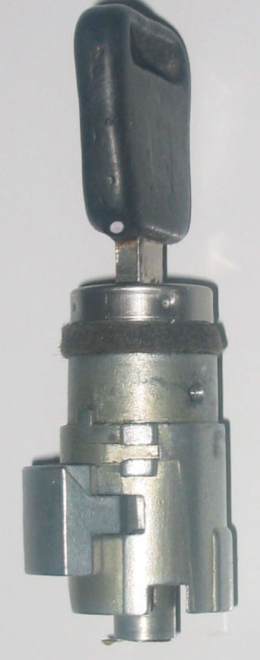

Vehicles with factory alarm will have a longer key, which adds 4 pins to the basic 10. When you take the core out of the barrel make sure you keep the key in it or everything will fall apart and you will have to find the small springs that are released. Hold the barrel vertically, key on top and pull the core up slowly out of the barrel. Place the core aside, key still in it, and look inside the barrel. Observe inside the barrel the 2 ridges opposite each other.

11

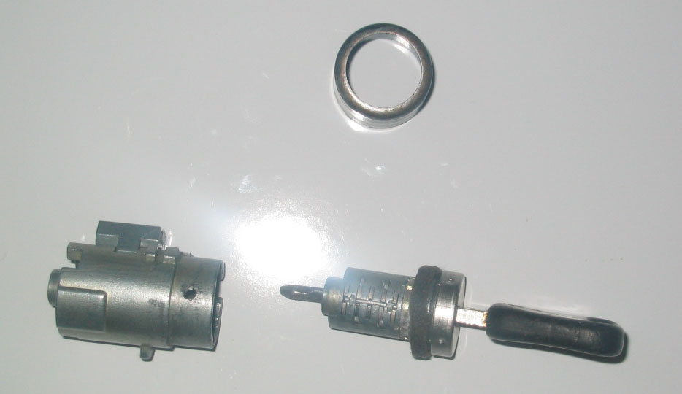

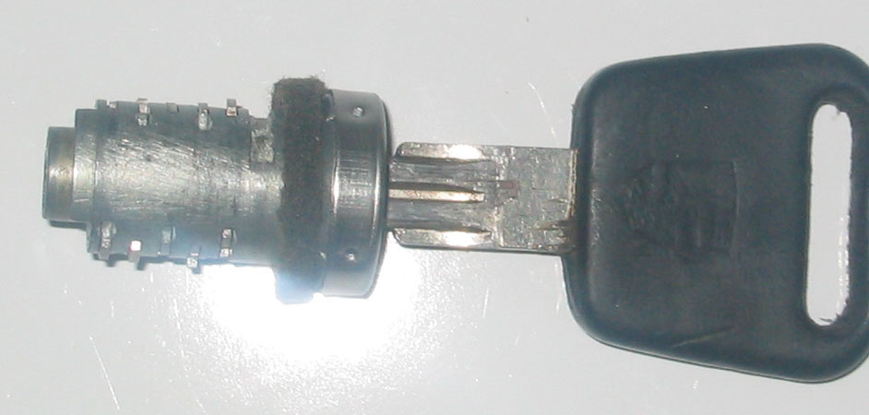

Do not let the actuator lever on the outside of the barrel move, or let the large spring that operates it come out. Observe and note where the ends of the spring are located as this spring returns (rotates) the actuator back to the lock engaged position. Slowly move the actuator and see how it works. Now this can be removed and cleaned. With the spring released the actuator will remove out the side of the barrel. The alarm core can now be dismantled for cleaning and rekeying.

12

Note the position of the core and barrel relationship, as the key will only operate the lock at a specific point. Mark the barrel (scribe a line in line with the key.) It is possible to install the core 180 degrees out of position.

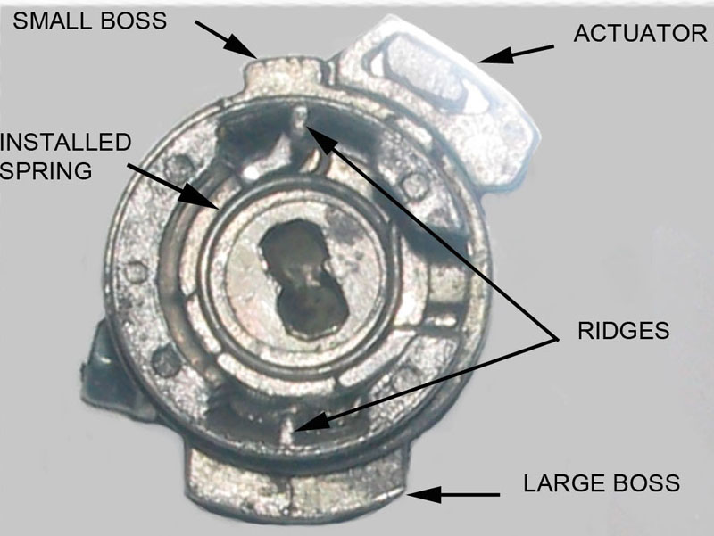

Barrel with alarm core, actuator, and spring

13

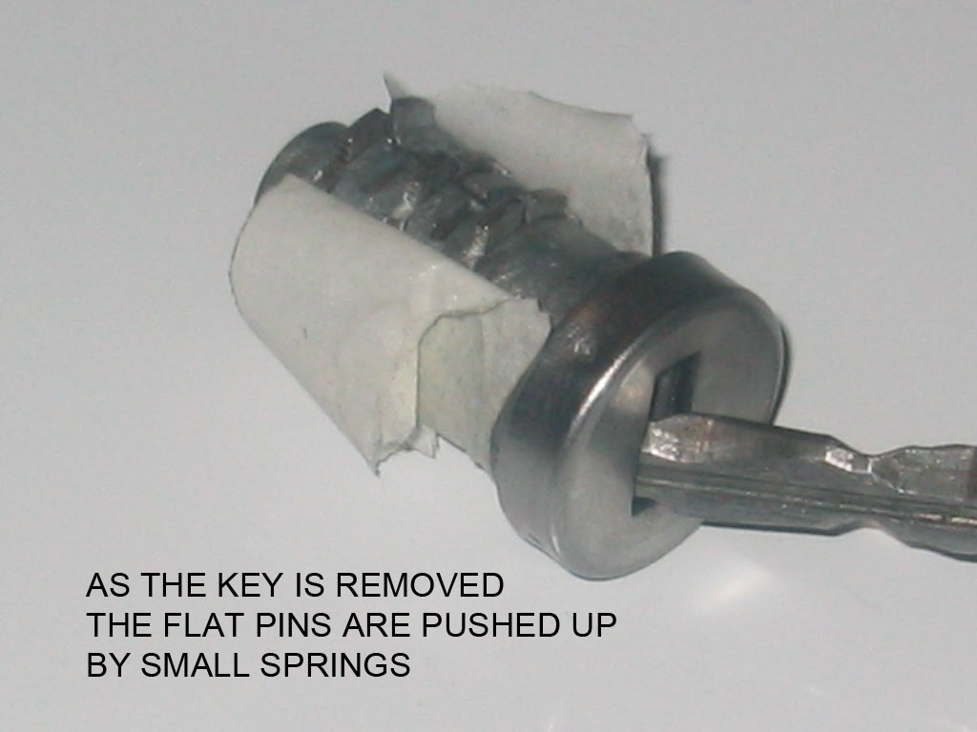

With the core and key assembly out of the barrel hold the core HORIZONTALLY and, with the key handle VERTICAL. Wrap masking tape around the bottom half of the barrel. Slowly pull the key out of the lock core. Stop at ¼” and observe how the rows of pins (as the springs push them up) form a groove. Remember above, inside the barrel the 2 ridges 180 degrees opposite each other. The pins will be located on each side of this ridge on reassembly, top and bottom.

14

Now (over the large bedsheet) remove the key, and, using tweezers remove the flat pins, or blades note the number (make a chart to record the location). Below each blade pin is a very small spring. Do not lose them. There are 6 pins on the bottom and 4 on the top. With the one side empty turn the core over and remove the tape and repeat the pin removal noting again which number went where. The top has 4 pins the bottom 6 when lock is installed in hatch or door. Clean everything and reassemble with a wipe of light oil or lithium grease. If rekeying a lock start with everything clean and lay out parts. i.e. groups of pins according to numbers etc.
Back to the clean empty barrel: Push the remainder of the drilled pins out of the barrel. I chose to tap the threads 6-32 and use set screws from HD sku 2241200884. They are a bit long and need to be shortened. Buy extra it’s cheaper than the gas to go back for more.
When tapping the barrel ensure the cap is on so you tap both together. Buy an Allen key that fits the screw. Alternative: just thread the barrel, then on final assembly run the screw into the barrel, put the cap on and then back the screw out tight against the inside of the cap, locking it. I would use a drop of cyanoacrylate on the screws. The screws only hold the cap on. They do not hold the core in the barrel as is the case with the door locks. Important: Deburr the inside of the barrel at the tapped holes.

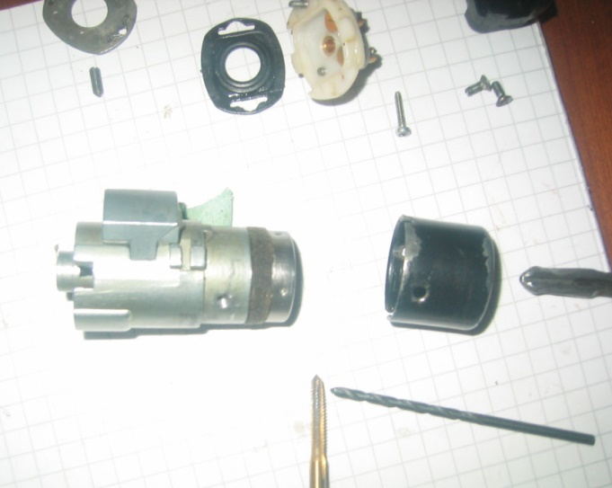

15

Index of parts

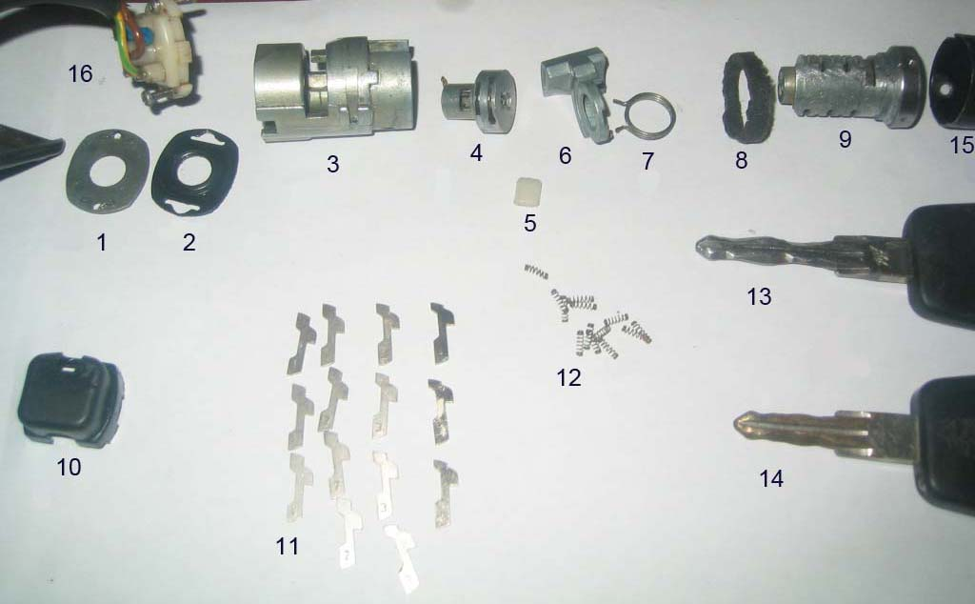

ITEM DESCRIPTION

- Alarm contact isolation plate
- Neoprene moisture seal
- Lock barrel housing
- Alarm core with contact finger
- Nylon bearing
- Actuator
- Spring
- Felt seal
- Lock core
- Alarm wire cover (plastic cap)
- Flat pins( numbered 1 to 4)
- Springs
- Alarm key
- Nonalarm key
- Barrel cap
- Alarm contact wire

16

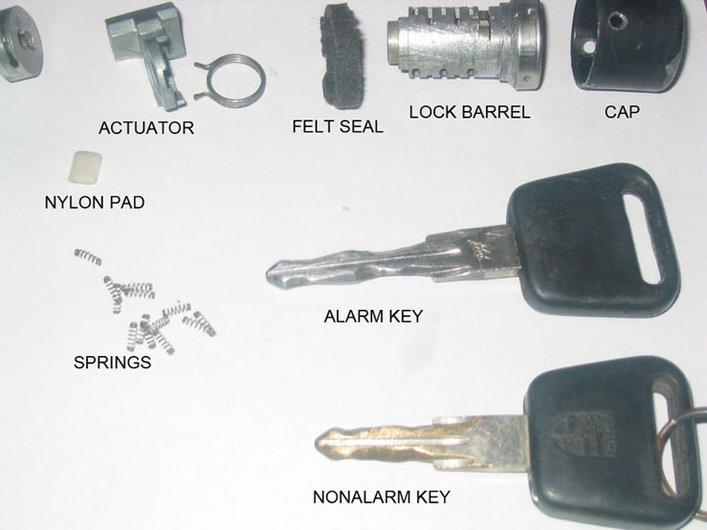

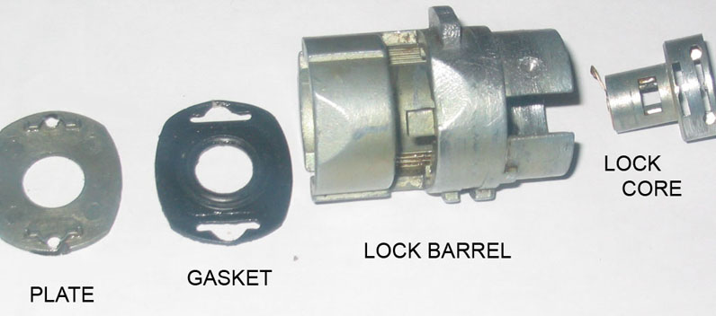

Additional pictures for reference only

17

REKEYING
Using tweezers place a spring and pin in the first hole then insert the key. If the pin is flush with the surface of the core, good, if on the side installed it sticks up (IS HIGH) go to the next Higher number, if too LOW the next Lower number. When the one side is done place tape over the pins and turn the lock core over. Repeat the process noting which number pin is in which slot on a chart. This chart will allow you to rekey the other locks to the same key much quicker.
If you have an alarm lock you will have 2 more pins on each side to deal with. The core for the alarm is done the same way, but on reassembly must be installed first, separately from the main lock as the actuator goes in between. The key is used as well but you must put the main core on the key so that the alarm section is held at the correct position on the" key" for determining the correct alarm pins. In other words do not try to set pins for alarm section without the main core on the key. Remember above how it was dismantled. The small alarm core with the copper tab must go in the correct way (pointing right) for the tab to touch the copper pins in the white nylon wire carrier when the key rotates it.
In summary: there are 4 different cut pins numbered, 1,2,3,4, plus 0, no pin, giving you 5 choices for each of the 10 main slots and 4 alarm slots.
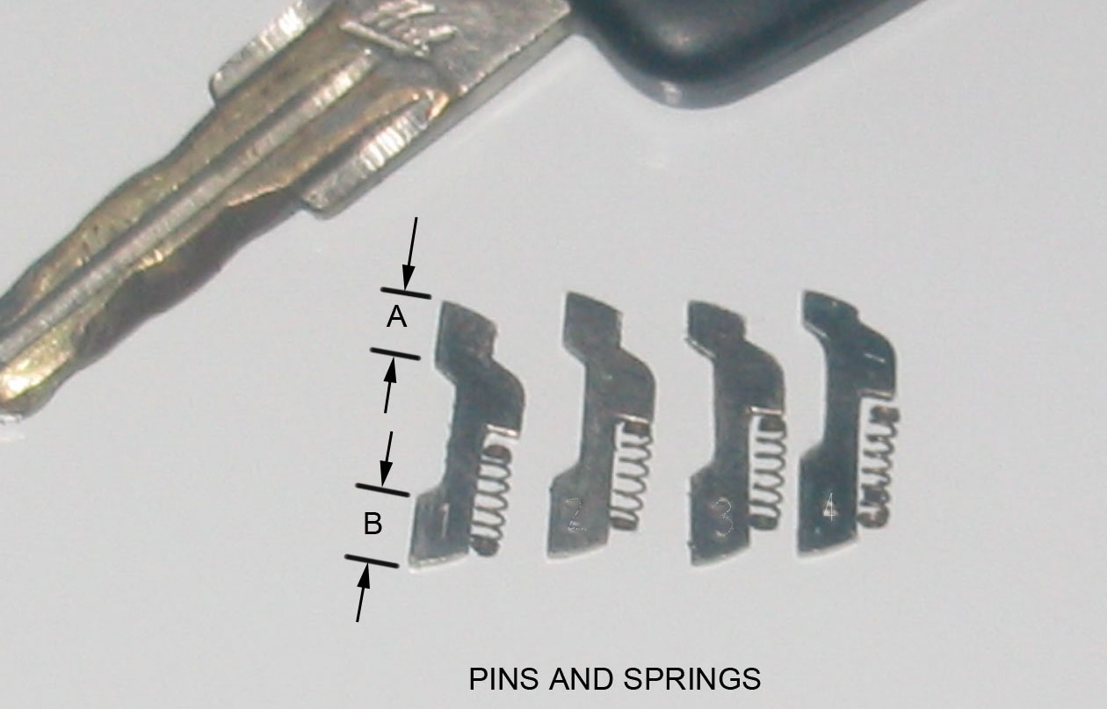
NOTICE HOW DIMENSIONS “A” AND “B” VARY FROM PIN NUMBER 1 TO 4

18

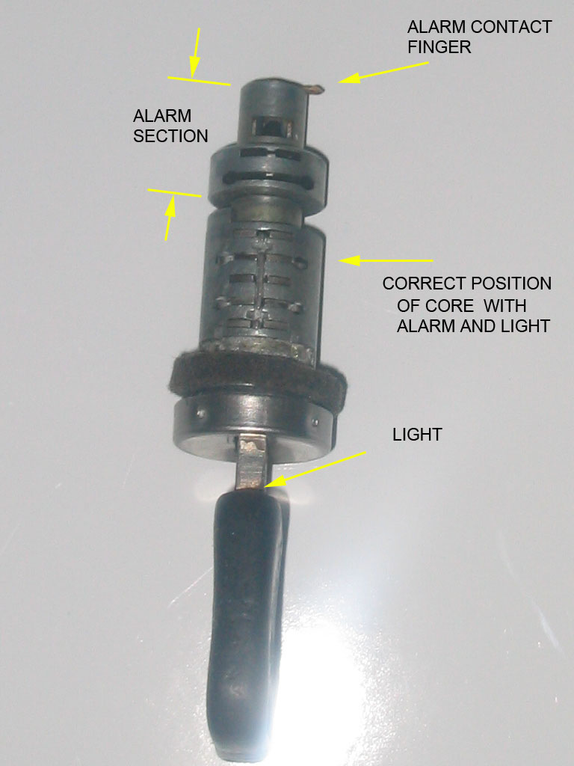

This is the correct position for setting alarm code pins.
Without main core on the key the alarm core will move closer to the key handle, and will change what the correct alarm code pins need to be. It is possible to install the core 180 degrees wrong, which is why I have stressed, key light, core, and barrel orientation.
The main core has 4 pins on the top side as shown above, (light on top and alarm contact finger pointing right.) and 6 pins on the bottom. The alarm core has 2 pins top and bottom.

19

MAKE A CHART as shown

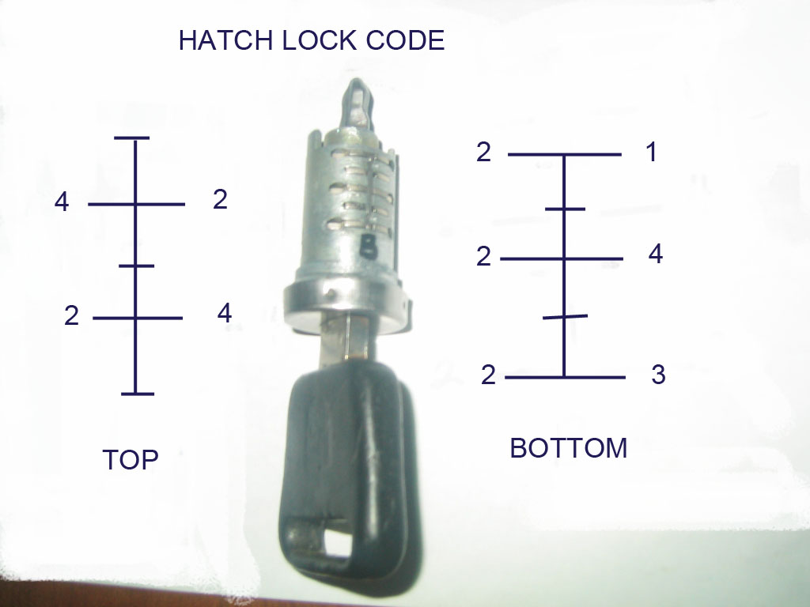

20

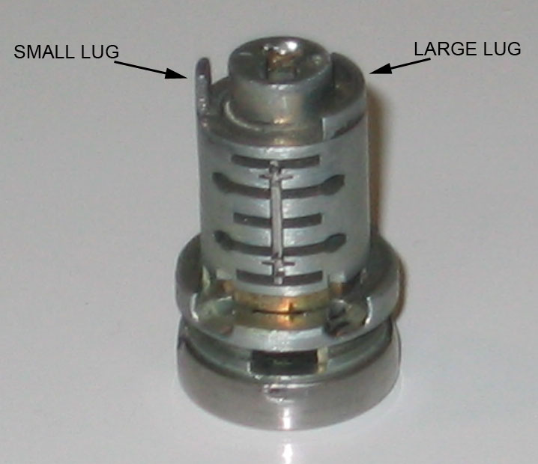

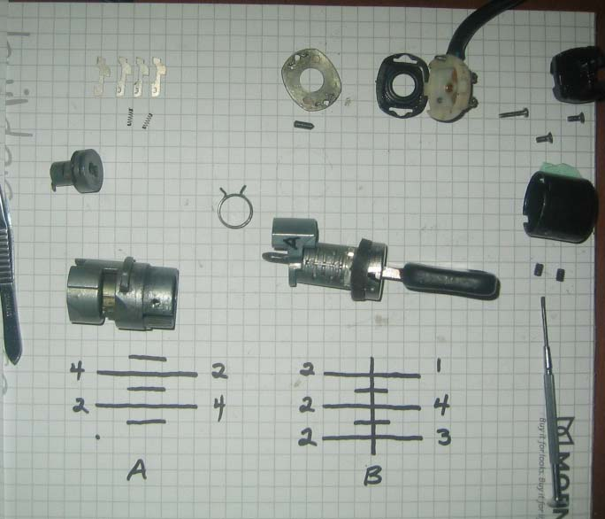

21

Clean again and assemble the core beginning with the alarm core, then the actuator and large spring, then the main core, using lock lubricant or lithium grease.
Remember the orientation of the barrel in the bracket, with the ridges and the groove created with pins. Hold the barrel with the casting boss that locks into the bracket, on top. The alarm core goes in with the contact tab pointing RIGHT. Use the key to insert this, then remove key. Without the key only gravity is holding it in so, the barrel must now remain vertical.
Slide the actuator in the side of the barrel. Hold it counterclockwise. You are now looking down into the barrel as you struggle with the spring. Amazing how such a simple part can take so long to install.

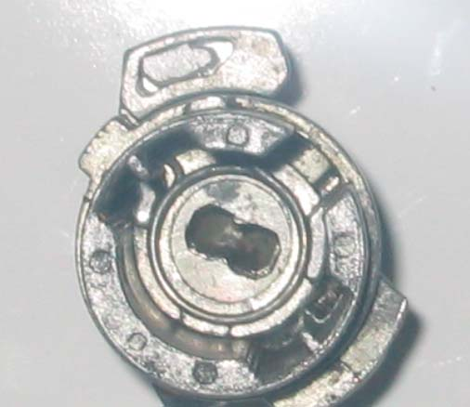
The actuator has a large flat radius base on which the spring sits. A trial fit will make sure you have the spring returning the actuator counterclockwise when viewed from the open end.
Holding the Barrel with the Small casting boss on top, and the key Vertical, Light On Top, install the core so that the Small Lug is on the Left, and Large Lug is on the Right.

22
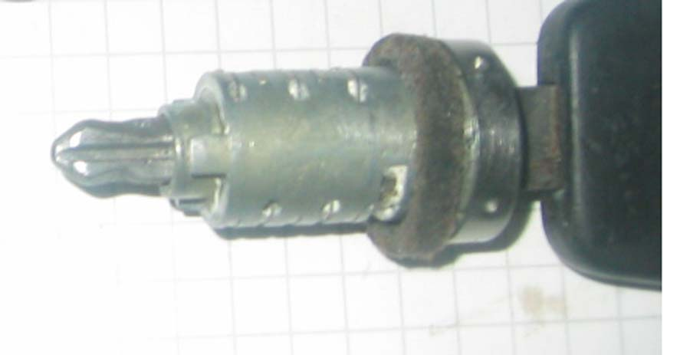

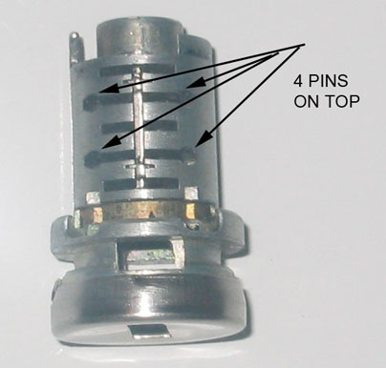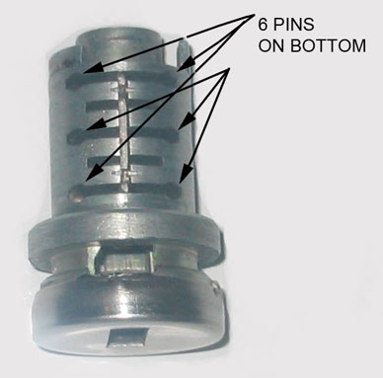

If horizontal the core will have 4 pins on top 6 on the bottom. This is how it should sit in the barrel and the actuator. The key turns clockwise to open so the core must fit into the actuator so that it will turn the required amount.

23

If the movement is smooth replace the cap and insert set screws. Install in bracket. Reassemble the other end of the alarm system. When installing the neoprene gasket and metal plate (items 1, and 2 in index of parts) put no strain on the copper finger. You will now have a lock that is ready to reinstall

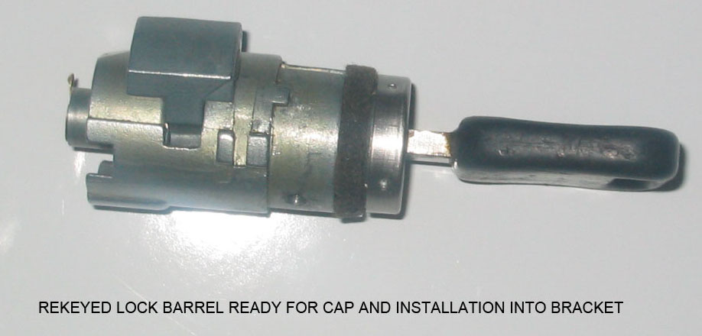

On assembly I used dry lube p.t.f.e. spray on the pins and white lithium grease in the barrel... Good luck.

Throughout I have not used the term “tumbler “as nothing tumbles. The key is machined with a symmetrical wave pattern. It simply aligns different pins against the tension of small springs to permit the centre core to turn inside the barrel. When the key is removed the springs push the flat pins up, on each side of the top and bottom ridges preventing the core from rotating inside the barrel.
I would also advise against filing the edges of the flat pins since doing so, you will create a lock nearly impossible to duplicate. Rather leave them standard and omit both spring and pin if none fit. Recording the standard flat pin numbers (code) will allow future keys to be cut and locks to be rekeyed that will fit the rest of the car.
I would also like to acknowledge that some of the pictures and information used here were garnered from others on Rennlist, I thank you. If you have any questions or find this vague or incorrect please contact me and I will make the necessary changes.

Wayne Strutt 2012 24
GAS CAP Wayne Strutt winter 2012

The Gas cap has no metal lock barrel retainer and will need no drilling. Inside the cap between the red and white sections are three molded plastic retaining flanges, (on the red part) that lock onto the shoulder of the white center section. Warm the red portion with hot water or a heat gun until the flanges are flexible, and, using three hands and 3 flat blades, CAREFULLY force back the tabs while pushing on the key to press the white section out of the red cover.

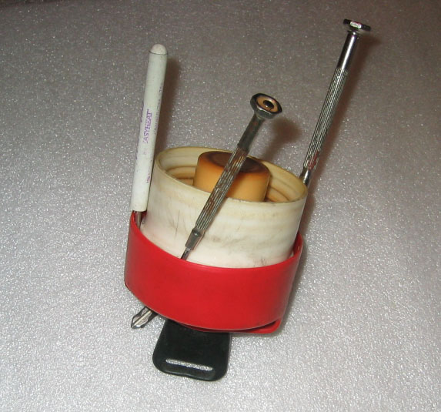

25

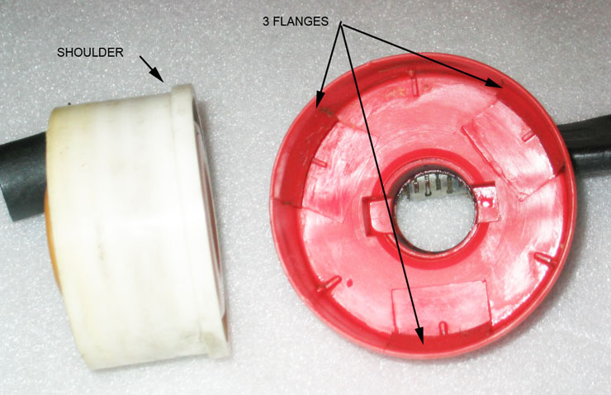

Now the black plastic lock barrel assembly can be removed from the white section, carefully as there is a white plastic ratchet pawl that is spring loaded inside the end of the black plastic barrel.
This locks or unlocks the outer red cap to the inner white section and makes the ratcheting sound when the locked cap is turned.

26

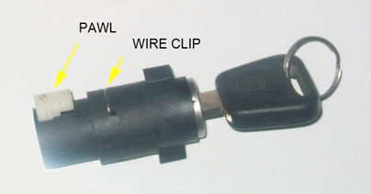

Just up from the spring loaded button is a wire clip inserted in the side of the black barrel which holds the core in place. Remove that with a small screwdriver.

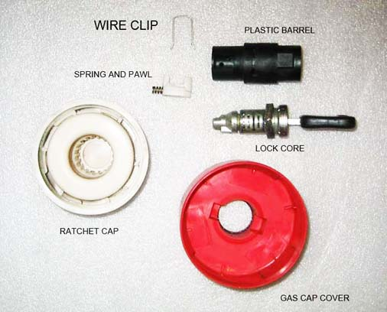

Insert the key and pull the lock core out of the black housing.
Insert the key you want to use and rearrange the flat pins to suit as outlined above. Remember there is a tiny spring under the shoulder of each pin. Don't lose them. When pins are done lubricate, slide the core into the black barrel, and insert the wire locking clip.
On reassembly, you have to squeeze the spring loaded button to get the cam on the end of the black barrel to engage in a slot in the white section. When complete simply line up the black barrel rectangular body with the rectangular recess in the red outer cover and press the red cover back on and you are finished.

Gas Cap Lock Rekeying
Wayne Strutt 2012 27

PORSCHE 928 dOOR LOcks by WAYNE STRUTT
The door lock was damaged by someone attempting to gain access to my car. I ordered a used lock from 928 International. It would have to be changed internally to use my key.

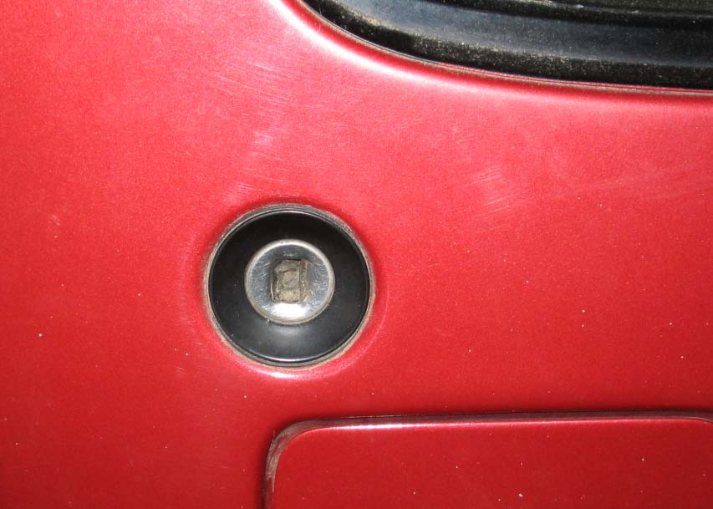

To access the door locks first open the door and remove the rubber plug just above the latch in the end panel.

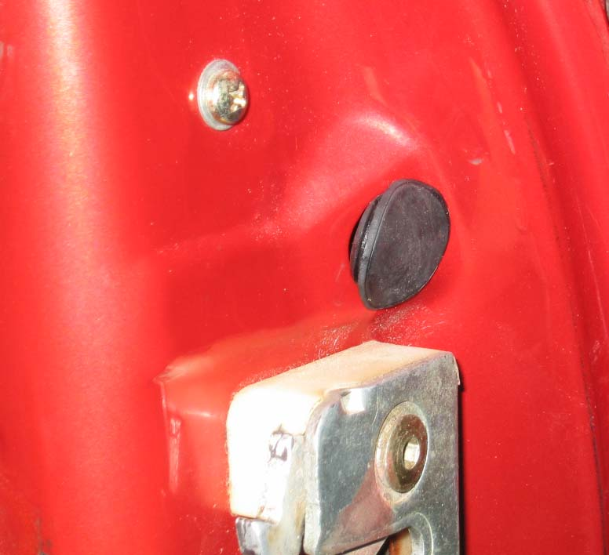

28
You will now see a 5mm Allen drive machine screw. Remove that screw carefully without dropping it or the 2 washers in to the door cavity or you will have to remove the inner door trim and panels to retrieve them.
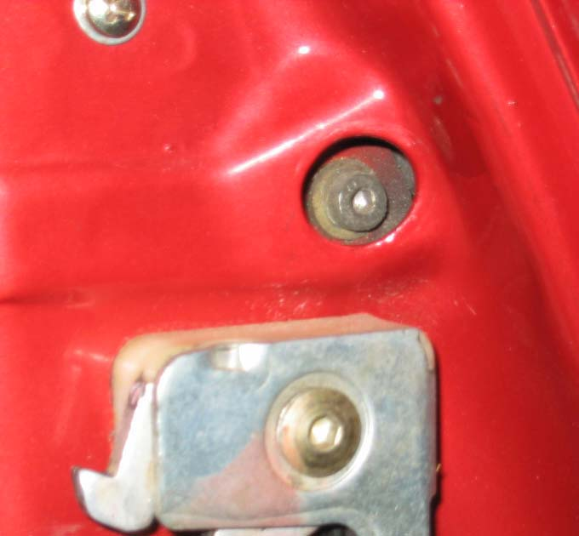

Now through that hole manipulate the lock body out through the outside of the door. Be careful not to damage the now old and brittle sealing washer around the back of the lock body. (If you plan on reusing it)

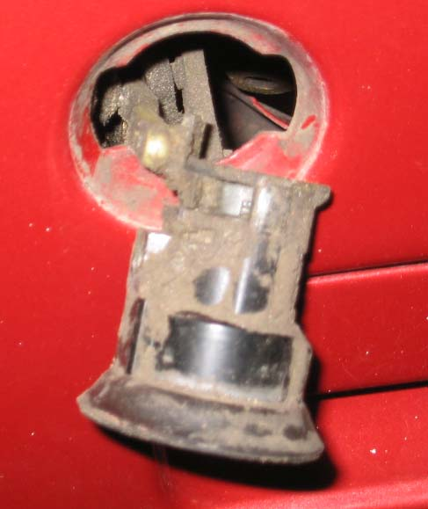
Once you can grip the lock with your fingers gently pull it out of the door far enough to facilitate removing the ball end from the socket in the lever.

29

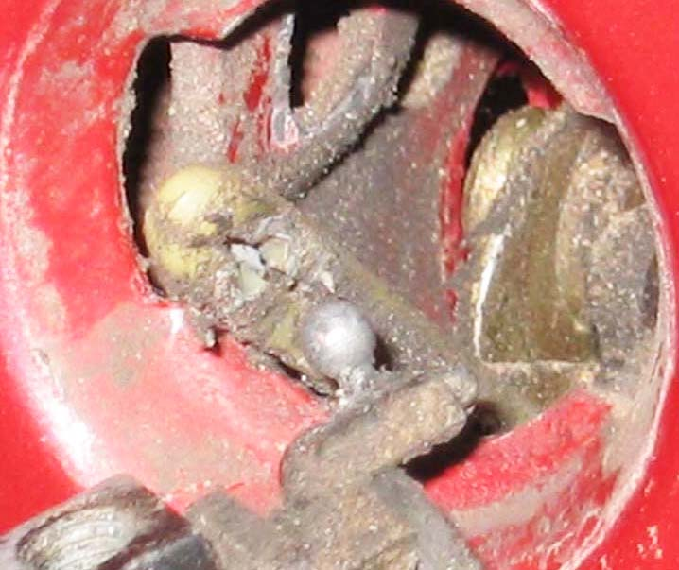
NOTE THE ACCUMULATION OF DIRT
Tie something to the nylon lever so that it does not drop beyond reach inside the door, or you will have to remove the inside door panels to reinstall the lock

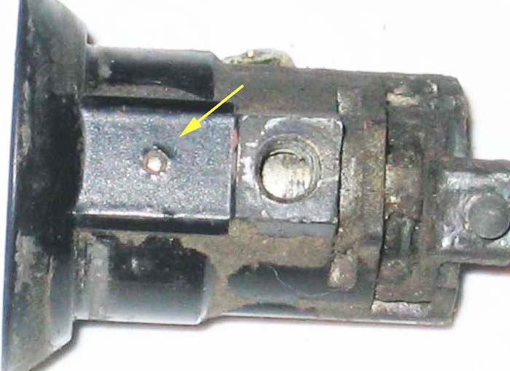
This picture shows one of the pins that hold the core in the barrel

30

The next step is to use a spring loaded centre punch on the tiny pins in the sides of the lock body. (About a million times).
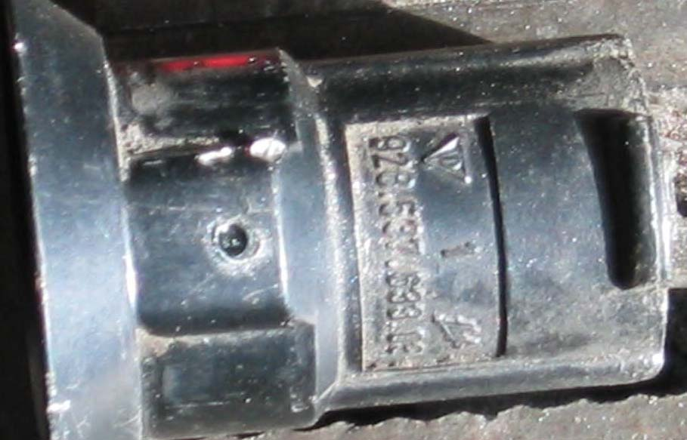
This will drive the pins down far enough to create enough of a recess to allow you to drill the pin on centre with a 1/16" drill bit. The lock body is about 3mm thick at this point but unlike the hatch lock if you hit the core you will not touch the area where the wafer pins are located, so drilling through will hurt nothing.

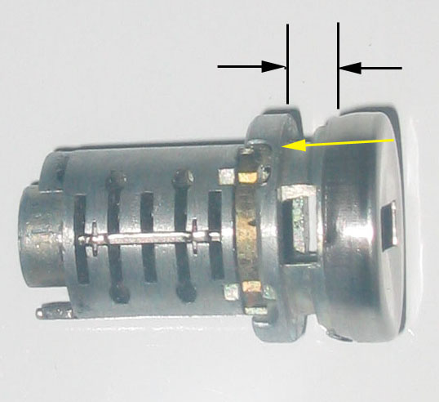

Original pins fit through the lock housing and locate between the black arrows and rest against the shoulder of the core at the yellow arrow preventing the core from coming out of the housing
31

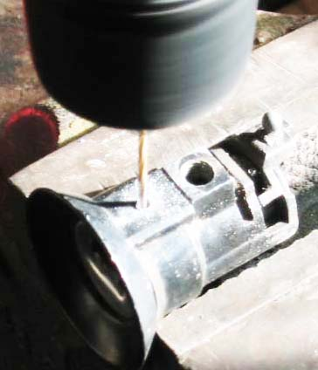
Drilling out pins
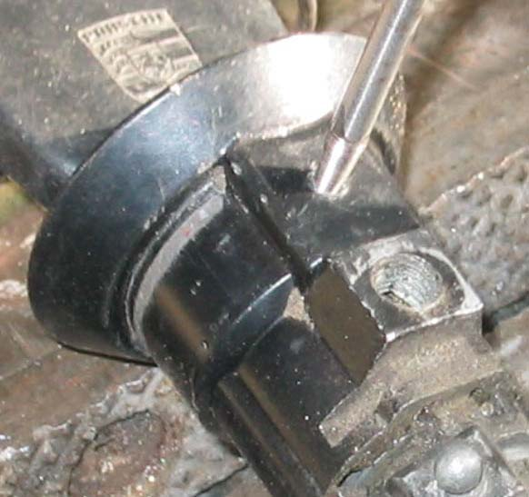

Using a diamond bit to erode the steel pin that I drilled off centre.
Once drilled out the core will be free to withdraw from the lock body. Keep the key in if you can as you do this. The spring on the end will be released. Don't panic this is easier to reinstall than the spring in the hatch lock. Again we have an actuator this time with a ball end that removes out the side of the lock body.

32

The pins that were drilled need to be replaced somehow. The internal depth of the pins is critical. The new pins when installed must be long enough to locate in the recess of the core to keep the core from coming out of the lock body but not so long as to jam the core and prevent it from rotating. Alternately you could tap the drilled holes and fabricate proper length screws that do this job. However they need to be nearly flush with the outer surface of the lock body so that they will fit through the cutout in the door. You could open the cut out in the door a bit if necessary. I drilled the body of the lock with a 1/8" bit and tapped the holes 6-32 and then using a 3/8 bit cut a bit of a recess for the screws.
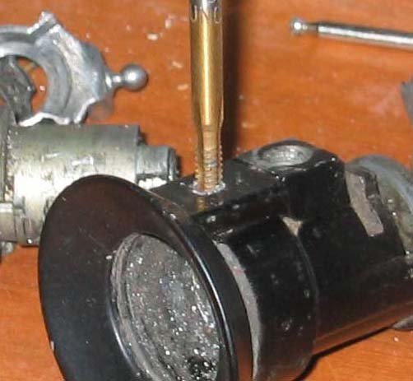
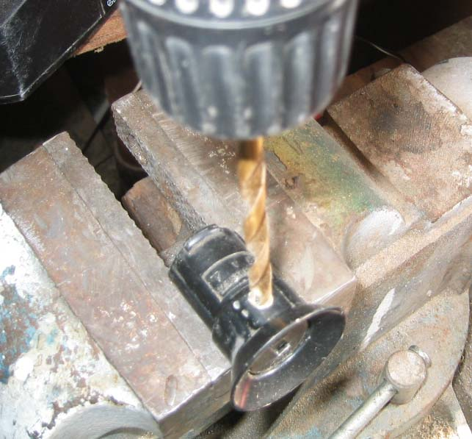
Drilling counter sink recess for screws
33

I used screws for home wall switch plates and shortened them for rotation clearance. Diameter of the screw where the thread is not needed is reduced with a file before shortening
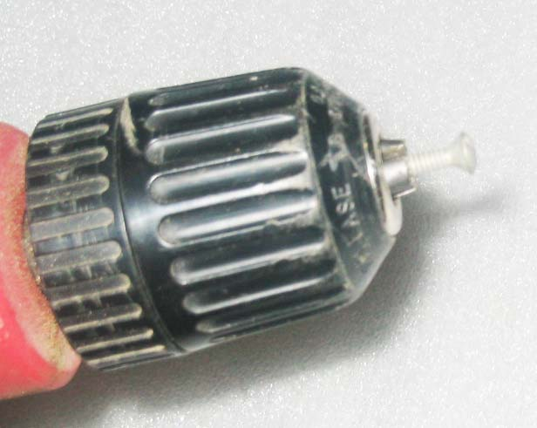

You might get by using just one screw on the same side as the tapped hole that bolts the lock to the door. The barrel of the lock is thicker on the tapped hole side, so the pin or screw on that side will be longer.

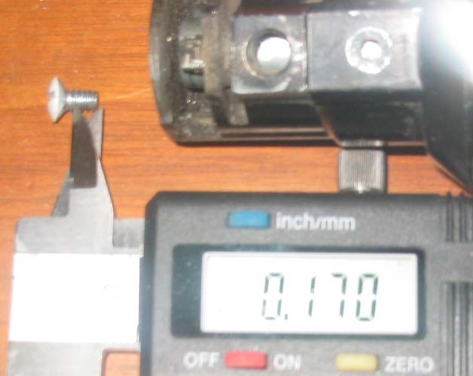

34

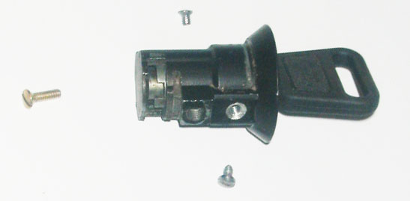

Once you have this under control turn your attention to the lock core. The core is very much like the hatch core with the basic 10 pins and additional alarm pins. Follow the same procedure for rekeying as outlined above for the hatch lock. Again record your code as above.

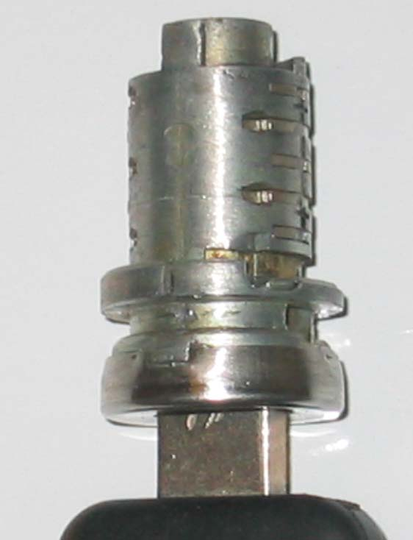
If you are rekeying to other locks that you have done use the same pins as you have already recorded in your chart. Check that you have smooth rotation. If you have an alarm lock there will be wires to unplug and the usual contact carrier as shown in the photo. Again be mindful of the fragile copper finger. Spray the pins and core with ptfe .
35

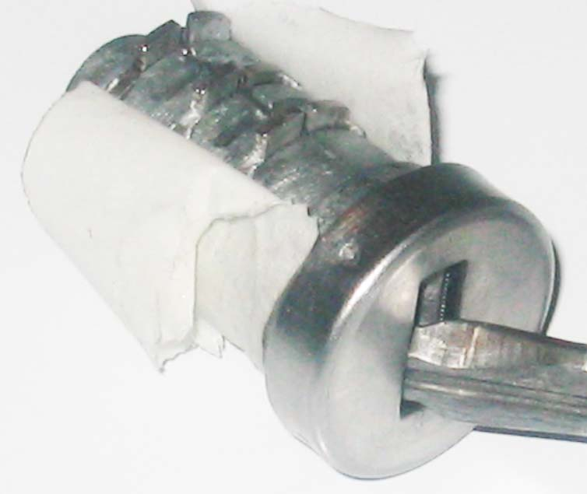
Once the core is rekeyed and the screws fit as needed you can begin reassembly. Apply a slight amount of lithium grease on the surface of the core. Not too much or it will just attract dirt.
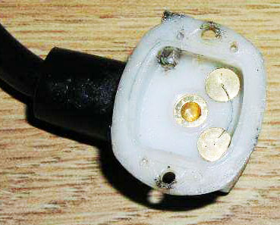

36

WITH THE KEY REMOVED THE FLAT PINS ARE PUSHED UP BY THE SPRINGS TO LOCK ON TO EACH SIDE OF THE BARREL RIDGES PREVENTING THE CORE FROM ROTATING.

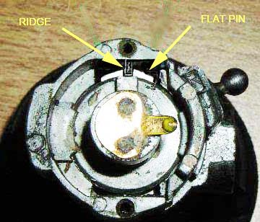

SHOWN IS THE ALARM CONTACT OF A DOOR LOCK
Once the core is rekeyed and the screws fit as needed you can begin reassembly.

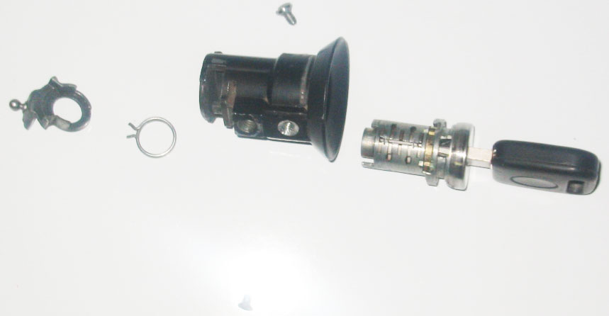

37

Put the spring on the end of the core with one tang against the side of the small lug as shown in the picture at the yellow arrow

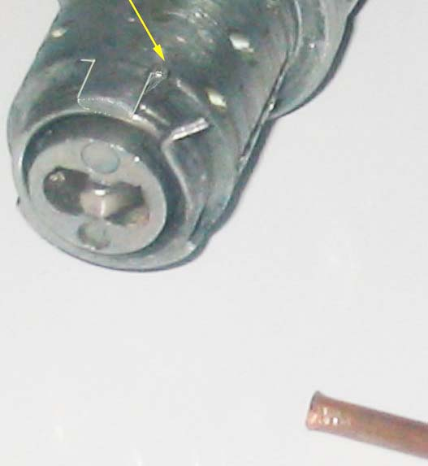.

Then using something suitable (I used a piece if 1/16th copper tubing), move the other tang over to the other side of the same lug.
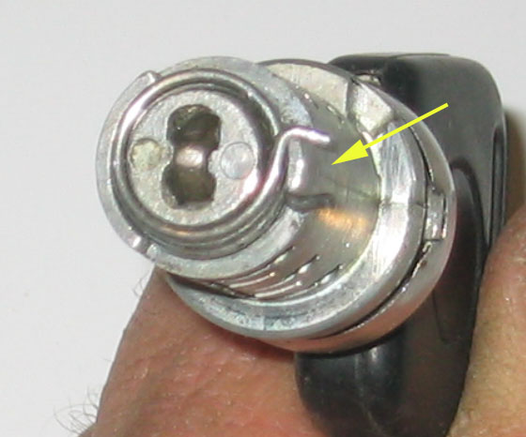

38

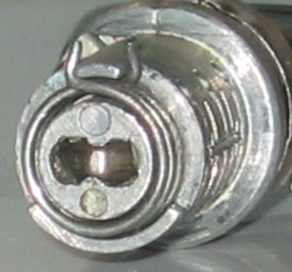

Install the actuator with the ball end into the side of the lock body. Now align the two small lugs one on the core and one on the barrel and push the core into the barrel. The spring will automatically be in the correct position.

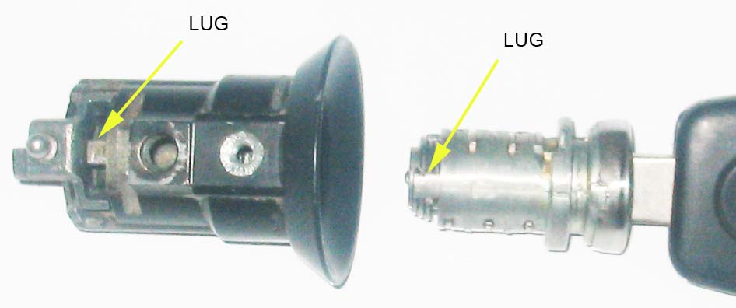

ALIGN LUGS WHEN INSTALLING CORE

39

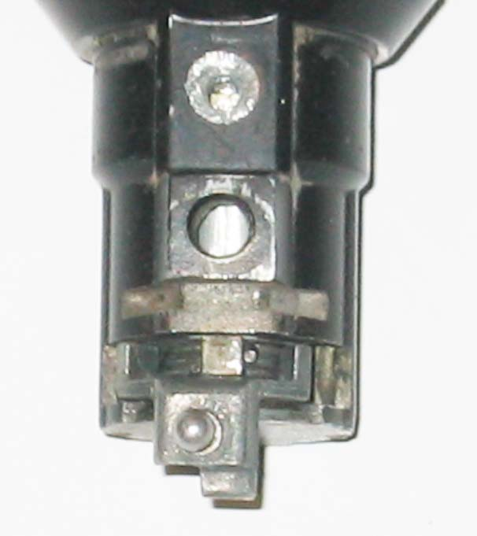
Spring installed, actuator installed, waiting for custom screws. With the screws tight turn the key left and right. It should turn smoothly and the spring should return the key to the vertical position.
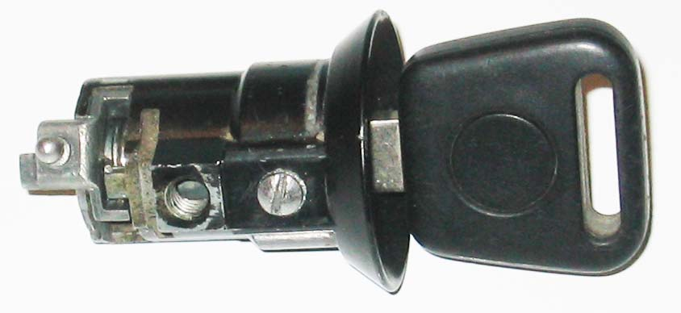
COMPLETED DOOR LOCK

If you are satisfied with the action, then unscrew the screws just enough to put some red loctite on the threads and re- tighten them. Put the gasket on the back of the lock barrel and push the ball into the socket of the lever. Install the lock into the door. Replace the 5mm socket head cap screw. Replace the access plug and you are finished.

40
WAYNE STRUTT 2012 PORSCHE 928 locks.

